Report Submitted to: DHS
Contract/Grant: DHS Contract No. 2012-DN-077-ARI057-03

Title: “ARI; Experimental and Computational Assessment of Unique Trace Elements and Isotope Ratios in Plutonium from Depleted Uranium Irradiated in Fast Reactor Blankets”

PD/PI: Sunil S. Chirayath
Associate Director, Nuclear Security Science and Policy Institute and
Visiting Assistant Professor, Department of Nuclear Engineering
sunilsc@tamu.edu Office Phone: (979) 862-2616

Submission Date: 29 May 2015

DUNS No. 847205572 EIN: 741974733

Recipient Organization: Texas Engineering Experiment Station
1470 William D. Fitch Parkway
College Station, TX 77485-4645

Grant Period: 01 September 2014 through 30 April 2015

Reporting Period End Date: 30 April 2015

Report Term: Interim Progress Report

Signature of Submitting Official:

Sunil S. Chirayath, Ph.D., PD/PI
Annual Final Performance Report
Texas A&M Engineering Experiment Station at Texas A&M University
“Experimental and Computational Assessment of Unique Trace Elements and Isotope Ratios in Plutonium from Depleted Uranium Irradiated in Fast Reactor Blankets”

Introduction
This interim progress report summarizes the work accomplished during the 8-month period from September 1, 2014 through April 30, 2015 at the Texas A&M Engineering Experiment Station (TEES). The work was performed in support of the DHS Contract No. 2012-DN-077-ARI057-03 entitled “Experimental and Computational Assessment of Unique Trace Elements and Isotopes Ratios in Plutonium from Depleted Uranium Irradiated in Fast Reactor Blankets.” This interim progress report also summarizes the work plan for the next four months remaining in this fiscal year of the contract/grant.

The report is organized into five major sections:

A. Major Goals -- the purpose and major goals of the project.

B. Accomplishments and Plans
-- the specific objectives, major activities, significant results, and key outcomes of the project for each of the two research teams during the reporting period.
-- the main activities to be undertaken during the next reporting period for each of the teams.
-- training and development opportunities provided by specific team research activities.

C. Dissemination -- products, publications, and other communications or outreach activities.

D. Participants -- descriptive list of the project participants (including students) supported by the contract/grant.

E. Budget Summary -- current budget on the requested template.

A. Major Goals
This project was originally planned as a three-year, multi-disciplinary effort, led by the Nuclear Security Science and Policy Institute (NSSPI) of the Texas A&M Engineering Experiment Station (TEES) at Texas A&M University (TAMU). The project has secured a no-cost extension into the fourth year. The overall purpose of this project is to use computational and experimental methods to determine whether it is possible to reliably predict and measure an intrinsic physical characteristic in weapons-grade plutonium (Pu) produced in reactors in foreign nuclear fuel cycles. The particular reactor types of interest are fast breeder reactors (FBRs) with depleted uranium blankets and CANDU-type reactors with natural uranium fuel. Our descriptive working title for the project is “Nuclear Forensics Analysis of Separated Plutonium of foreign fuel cycles (NFASP). The NFASP project aims to produce the following outcomes:
- Nuclear forensics analysis of weapon-grade Pu produced in fast breeder reactor (FBR) blankets and thermal reactor (CANDU reactor) low-burned fuel (1GWd/t).
- Experimental verification of weapon-grade Pu fingerprints originating from unique foreign nuclear fuel cycles.
- Development of a national nuclear forensics capability for targeting weapon-grade plutonium produced from low burned fuel assemblies in foreign nuclear fuel cycles.
- Separation of Pu from fission products and uranium using a benchtop-scale PUREX reprocessing process and characterization of this Pu by destructive and nondestructive analyses. In addition to verifying our computational analyses, these results will be used as teaching and demonstration tools for graduate and undergraduate students.
- Mentoring, educating and supporting a post-doctoral researcher and graduate and undergraduate students.
- Publications through student presentations in technical conferences and scholarly journals.

In Fiscal Year (FY) 2013, DHS reduced the budget for this project by $124,363. However, an additional $67,400 was provided in FY 2014. This overall funding reduction of $56,963 led us to suspend the planned irradiation of surrogate CANDU reactor natural UO₂ fuel in FY 2014. With the available funding we are fabricating the natural UO₂ fuel samples with services from ORNL, which is in the final stages and ready to ship to TAMU campus. The assumption is that additional funding can be secured either from DHS or some other funding agency in the future to complete the neutron irradiation and experimental forensics investigation on irradiated natural UO₂ fuel samples.

The NFASP project is being executed by two designated research teams, each led by a different Co-PI. NSSPI is managing the overall integration of these two teams to produce the completed nuclear forensics analysis method for weapon-grade Pu produced in fast reactor blankets and thermal reactor low-burned fuel (1GWd/t). The roles and functions of each individual research team are summarized below:
1. Neutronics and Uranium Irradiation Team -- Overall Purpose: The Neutronics and Uranium Irradiation Team develops high fidelity reactor core neutronics and fuel burn-up models for FBR and CANDU reactors to compute the isotopic content in low burn-up discharged fuel. This team is also responsible for planning and coordinating the neutron irradiation of samples of uranium dioxide (UO₂) fuel pellets in a fast spectrum to simulate FBR and in a thermal spectrum to simulate CANDU at the ORNL high flux isotope reactor (HFIR) for experimental validation of the computed results.
2. Chemical and Forensics Analysis Team -- Overall Purpose: The Chemical and Forensics Analysis Team will generate and provide data to demonstrate a nuclear forensics analysis method for weapon-grade Pu. The data generation will be accomplished through chemical analyses of separated Pu (using the benchtop-scale PUREX reprocessing process) from irradiated UO₂ samples and also by trace elemental analyses of the residual solutions from the benchtop-scale PUREX process. The trace elements thus found in the residual solutions can be looked for as trace contaminants in the separated Pu. The results of this analysis will be useful for identifying which variations of the PUREX process (i.e., types of chemicals, concentrations, etc.) were used to separate a given Pu sample.
The above research teams employed students and faculty from Texas A&M University, including from the departments of Nuclear Engineering, Chemistry and Physics. The project in this fiscal year has supported 1 undergraduate student (White) and 3 graduate students (2 Whites and 1 Hispanic). A female graduate student (Hispanic) funded through fellowship also worked in this project. In addition a post-doctoral research associate (Asian) also worked in this project. The total number of students supported since the beginning of the project (in FY 12, FY 13, FY 14, and FY15) is 4 undergraduate students (4 Whites), 8 graduate students (5 Whites, 2 Hispanics and 1 African American) and a post-doctoral research associate (Asian).

B. Accomplishments and Plans
This section describes the specific objectives, major activities, significant results, and key outcomes for each of the two designated research teams during the reporting period. It also includes a summary of each team’s plans for the remainder of the project (i.e., through 31 August 2015). As appropriate, specific examples of training and professional development progress are described in connection with individual team or research thrust activities.

1. Neutronics and Uranium Irradiation Team
The neutronics and uranium irradiation research team focused on two major research thrusts and the progress made in each of these two thrust areas is described separately below.
Thrust-1: Computational Reactor Modeling and Simulations for Isotopic and Fission Product Signatures. The objectives of this research team are to (i) develop a model of the Indian 500 MWe FBR, (ii) develop a model of the 220 MWe CANDU reactor, and (iii) conduct 3D neutron transport simulations using these core models to estimate isotopic inventories in the irradiated fuel discharged at low burn-up (1GWD/t). In addition to this, objective (iv) is to suitably modify the ORNL-HFIR MCNP model to better simulate the neutron irradiation experiments planned by accurate representation of the irradiation capsule holding the UO₂ samples. This step is required to achieve the desired neutron spectrum environment for the simulations of experimental neutron irradiations planned for depleted UO₂ (simulating FBR blanket) and natural UO₂ (simulating the CANDU fuel). The latter activity, simulating CANDU fuel sample irradiation, is suspended because of the reduction in funding.
Accomplishments: Objective (i) was accomplished in FY 12. Objective (ii) was accomplished in FY 13. Part of the 3D neutron transport simulations of objective (iii) was completed in FY 13 and the remaining was completed during FY 14. Objective (iv), which is modeling the ORNL-HFIR using the MCNPX code to simulate the FBR blanket fuel irradiation in a fast neutron environment was completed during this reporting period of FY 14. Since the CANDU fuel sample irradiation was suspended due to lack of funding, that part of objective (iv) is not being taken up. Hence the computational aspects of this project had nothing to be accomplished during this reporting period other than coordinating with Forensics and Analysis Team.
From the analysis of burnup and transport simulations carried out so far, the team was able to identify the following isotope ratios (Table-1) that would be suitable as characteristic signatures to identify the source reactor type of separated plutonium. The results in Table-1 show that there are marked differences in these isotope ratios between FBR blanket fuel and CANDU fuel.

Table-1: Ratio (CANDU-to-FBR) of Fission Product Contaminant Mass per Kilogram of Separated Plutonium with a PUREX Decontamination Factor of 10⁶
Isotope | Ratios
Isotope | CANDU/FBR Expected Mass Ratios  For example:
Prompt Gamma
Cs-137/Pu | 12.86
Ce-144/Pu | 28.80
Delayed Alpha
Pu-239/Pu | 0.98
Pu-242/Pu | 19.77
Gamma
Cs-134/Pu | 3.16
Sb-125/Pu | 5.93
Eu-154/Pu | 3.72
Mass Spec.
Rb-85/Pu | 19.00
Sr-90/Pu | 22.29
Nd-148/Pu | 12.51
Pm-147/Pu | 15.48
Sm-150/Pu | 107.99

In addition to the fission product-to-plutonium ratios presented in Table 1, we also investigated the ratios of different isotopes of the same fission product element to plutonium (Table 2) to eliminate the potential differences in decontamination factor (10⁶ assumed constant to generate Table 1) between the chemical elements.
Table-2: Ratio (CANDU-to-FBR) of Same Chemical Element Fission Product Contaminant Mass per Kilogram of Separated Plutonium with a PUREX Decontamination Factor of 10⁶
Isotope Ratio of Same Element | Ratios
Isotope Ratio of Same Element | CANDU/FBR Expected Mass Ratios  For example:
¹³⁴Cs/¹³⁷Cs | 0.25
¹⁴⁴Ce/¹⁴²Ce | 1.92
¹⁵⁰Sm/¹⁵⁴Sm | 17.6
²⁴²Pu/²³⁹Pu | 20.2

From both Table 1 and Table 2, it can be inferred that there are marked differences in these isotope ratios between FBR blanket material and CANDU fuel. If trace quantities of these fission products can be measured in an interdicted plutonium sample, these isotope ratios should provide significant aid in identifying the source reactor type.

Analysis of MCNPX simulation results for depleted UO₂ fuel sample burnup calculations with the ORNL-HFIR model, which simulated FBR blanket material irradiation in a fast neutron environment was completed in FY 14. Comparison of experimentally measured fission product concentrations in the neutron irradiated sample with that obtained from the computational simulations was continued in this reporting period. The experimental measurements were made by nondestructive assay of the neutron irradiated depleted UO₂ pellets (received from ORNL at TAMU) using gamma spectrometry and destructive analysis using the PUREX chemical process. The results obtained are presented in Table-3.

A manuscript communicated in December 2013 to the Journal of Science and Global Security based on the CANDU and FBR reactor simulation studies carried out by the MS students Taylor Coles and Jeremy Osborn was reviewed by the referees and accepted for publication in December 2014 and is made available on line in March 2015. The title of the paper is “Trace Fission Product Ratios for Nuclear Forensics Attribution of Weapons-Grade Plutonium from Fast and Thermal Reactors”

Table-3: MCNPX Predicted and Measured Fission Product Radioactivity of Neutron Irradiated Depleted UO₂ Sample
Radioisotope | Measured Radioactivity (Ci/g) | Measurement Uncertainty (%) | MCNPX Predicted Radioactivity (Ci/g)* | Predicted/Measure-  ment Ratio
Ce-144 | 9.14E-02 | 4.72 | 7.29E-02 | 0.80
Cs-134 | 2.01E-03 | 7.54 | 2.02E-03 | 1.01
Cs-137 | 1.47E-02 | 3.01 | 1.15E-02 | 0.79
Eu-154 | 1.70E-04 | 6.28 | 1.79E-04 | 1.05
Ru-106 | 6.90E-02 | 8.06 | 7.38E-02 | 1.07
Sb-125 | 1.27E-03 | 5.21 | 1.55E-03 | 1.22
Zr-95 | 4.82E-03 | 4.27 | 5.07E-03 | 1.05
* Uncertainty in MCNPX predictions from stochastic methodology is less than 10%

Plans (May 1, 2015 through August 31, 2015):

- The principal investigator will seek funding opportunities for CANDU natural uranium dioxide sample irradiations and experimental investigations.

Training and Professional Development: Two graduate students, Mathew Swinney and Jeremy Osborn worked in this thrust area in this fiscal year. All the students were trained by the team lead, Dr. Chirayath, in the following areas: use of MCNPX radiation transport code, the theory behind the code, performing simulations of reactor core neutronics, and analyzing the results generated by the code. This code system is a valuable tool for carrying out 3D neutron and photon radiation transport simulations for various purposes.

Thrust-2: Neutron Irradiation of Uranium Dioxide (UO₂) Fuel Pellets. The goal of this thrust area is to coordinate in-reactor irradiations at ORNL-HFIR and then provide the irradiated samples to the TAMU Chemical and Forensics Analysis Team which will separate plutonium using the PUREX process. In this project we envisaged to irradiate two sets of uranium samples: (a) depleted UO₂ irradiation in fast spectrum neutrons (simulating the FBR case) and (b) natural UO₂ irradiation in thermal spectrum neutrons (simulating the CANDU case). The overall funding reduction of $56,963 led us to suspend the planned irradiation of surrogate CANDU reactor natural UO₂ fuel, chemical dissolution and comparison of lab results to computational results in FY 2014. With the available funding, we are fabricating the natural UO₂ fuel samples with services from ORNL and will be shipped to TAMU within a month.. The assumption made is that additional funding can be secured either from DHS or some other funding agency in the future to complete the neutron irradiation and experimental forensics investigation on irradiated natural UO₂ fuel samples.

Accomplishments: Coordinated with ORNL on the fabrication work is in progress at ORNL under the work-for-others agreement (Agreement No. NFE-14-05210 TEES), and the fabrication is complete and we are expecting to receive it from ORNL in month of June 2015.

Other important accomplishments include:
- Mathew Swinney who worked in this thrust area defended his PhD dissertation proposal successfully on December 15, 2014.

Plans (May 1, 2015 through August 31, 2015):
- The natural UO₂ samples will be shipped to TAMU from ORNL in June, which will be coordinated for receipt in consultation with the radiation safety officer at TAMU.

Training and Professional Development: One graduate student, Marlene Bencomo was trained to handle the UO₂ samples and in the preparations for receiving it here at TAMU.

2. Chemical and Forensics Analysis Team
Experimental Investigations of Irradiated UO₂ pellets through Chemical Separations of Pu. The goal of this research is to conduct comprehensive isotopic and chemical analyses of small quantities of irradiated uranium fuel needed to validate the detailed computational predictions of the Neutronics Team. They have determined that the nuclides of greatest forensic interest are ²³⁹Pu, ⁸⁵Rb, ⁹⁰Sr, ¹²⁵Sb, ¹³⁷Cs, ¹³⁴Cs, ¹⁴²Ce, ¹⁴⁴Ce, ¹⁵⁴Eu, ¹⁴⁷Pm, ¹⁴⁸Nd, ¹²⁹I, ¹²⁵I, ¹³⁴Ce, ¹⁵⁰Sm and ¹⁵⁴Sm. The ratio ¹⁵⁰Sm/Pu is especially interesting because it should vary by more than a factor of 100 between FBR and CANDU reactors (refer to Table 1). The goal this project year has been to complete the assays of a sample of depleted UO₂ fuel that has been irradiated at the ORNL-HFIR. We have used a benchtop-scale PUREX process to recover the U and Pu, and standard radiochemical techniques to separate the other elements of interest. These radionuclides have been assayed via a combination of gamma spectrometry and inductively coupled plasma mass spectroscopy (ICP-MS). The results have been compared to calculations by the Neutronics and Uranium Irradiation Team. (See Table 3).

Accomplishments: In the final year of the project, we continued the destructive and non-destructive analyses of the irradiated fuel pellet. Preliminary measurements had been made in the previous project year, and significant radiochemical work was competed in the current year. The pellet of irradiated depleted uranium dioxide was dissolved in nitric acid for radiochemical analysis. Aliquots were taken, and a modified PUREX process was applied to them to purify the plutonium present. The start of a major renovation to the building containing the radiochemical laboratory interrupted the work for a few weeks while the laboratory was moved to another building, but the new laboratory is now fully operational. Data analysis continued during that time. A number of important forensic properties of the sample are being measured.
PUREX processing of the irradiated samples has been occurring on a routine basis. The radioactive material dissolved in HNO₃ is contacted with 30% tri-n-butyl phosphate (TBP) with kerosene diluent. Complexation of Pu and U with TBP causes these elements to move across the phase boundary into the organic phase with a high separation from fission products. Selective reduction of Pu using iron sulfamate [Fe(NH₂SO₃)₂] allows it to be back-extracted into a second aqueous phase. By combining multiple extractions into one “cycle,” good recovery of Pu and substantial purification from U has been obtained: After one cycle, 94% of Pu was recovered with a corresponding 90% reduction in U. After a second cycle, 86% of Pu was recovered but with a 99.6% reduction in U. After these two cycles, the amount of ¹³⁷Cs remaining is below the sensitivity of our HPGe detector, corresponding to a decontamination factor of >80 per cycle.
These analyses have allowed us to begin a forensic analysis of the sample. The results discussed above were obtained by destructive and non-destructive techniques. In addition to standard gamma spectroscopy, the samples were analyzed via inductively coupled plasma mass spectrometry (ICP-MS). Texas A&M University does not have an ICP-MS instrument available that can accept the radioactive samples, so the analyses were conducted at the University of Missouri Research Reactor (MURR). A broad range of masses have been quantified for many samples, and the agreement with calculated values is generally within 10% (see Table 3). Preliminary results suggest that the burnup of the fuel was ~4.8 GWd/t, much greater than the planned burnup of ~1 GWd/t. Discussions with the Neutronics and Uranium Irradiation Team suggest that this is consistent with the actual irradiation at Oak Ridge. These forensic analyses are ongoing.

Plans (through August 31, 2015): The Chemical and Forensics Analysis Team will continue its data analysis through the end of the project on August 31, 2015. We will continue to investigate which nuclides can be used to determine forensic properties of the sample. For example, ¹⁴⁷Nd can be used to estimate the neutron flux during the irradiation, ¹⁰⁶Ru can be used to determine the fissioning species, and ¹⁴⁴Ce can be used to determine the time since the end of the irradiation. Our measurements are largely complete, so we intend to use the data to determine the initial and final enrichment of uranium, the length of the irradiation, and the total fluence. A publication on these topics is in preparation.

Training and Professional Development: Dr. T. K. Bhardwaj leads the day-to-day radiochemical work on the project, which adds to the pool of trained personnel in the United States, and he presented his work at an American Chemical Society meeting in March 2015. He has also taught a lecture on radiochemistry to an undergraduate nuclear chemistry class and gave a graduate-level lecture to a nuclear engineering class on chemical assay methods and mass spectrometry. Profs. Folden and Chirayath have also worked with Dr. Bhardwaj to help him learn how to develop proposals, including developing ideas and preparing budgets. Mr. P. M. Mendoza is principally involved with the PUREX radiochemical work and is completing his Ph.D. while supported by the project. Three undergraduate students, Mr. J. R. Allred, Mr. J. D. Thyrion, and Mr. Robert Du also worked on a number of tasks as student workers.

C. Dissemination

During this Reporting Period (September 2014 through April 2015)

- Journal Paper: “Trace Fission Product Ratios for Nuclear Forensics Attribution of Weapons-Grade Plutonium from Fast and Thermal Reactors”, Sunil Chirayath, Jeremy Osborn and Taylor Coles, Journal of Science & Global Security, Volume 23, pp 48-67.
- Determination of Decontamination Factors for Various Radioisotopes During the PUREX Process of Irradiated DUO₂ Pellet, American Chemical Society National Meeting and Exposition, March 21-26, 2015, Denver, CO.

First year of the project (September 2011- August 2012)

- Oral and poster presentation on “Neutronics Analysis of Fast Breeder Reactor Core to Support the Plutonium Fingerprinting for Forensics (PuFF) Project”, Jeremy M. Osborn, Taylor M. Coles, Amanda R. Twaddle and Sunil S. Chirayath, 5th Annual Academic Research Initiative (ARI) Grantees conference during July 23-25, 2012, Leesburg, Virginia, USA.
- Oral presentation on “Assessment of Unique Trace Elements and Isotope Ratios in Separated Plutonium from Low Burnup Spent Fuel”, Sunil S. Chirayath, Charles M. Folden III and David R. Boyle, 5th Annual Academic Research Initiative (ARI) Grantees conference during July 23-25, 2012, Leesburg, Virginia, USA.

Second year of the project (September 2012- August 2013)

- Oral Presentation on “Nuclear Forensics Signature Analysis of Fast and Thermal Reactor Produced Weapons-grade Plutonium”, Jeremy M. Osborn, Taylor M. Coles, Amanda Rose Twaddle, Sunil S. Chirayath, William S. Charlton, in the technical track titled “Analytical and Chemistry Solutions to Nuclear Forensics Problems: Analytical Tools and Modeling”, Proceedings of the 245th American Chemical Society national meeting held during April 7-11, 2013, New Orleans, Louisiana, USA.
- Full paper accepted and Oral Presentation: “Neutronics Analysis of Fast Breeder Reactor Core to Support the Plutonium Fingerprinting for Forensics (PuFF) Project”, Jeremy M. Osborn, Sunil S. Chirayath, and William S. Charlton, in the Concurrent Session on “Nonproliferation and Arms Control and Materials Controls and Accountability: Nuclear Forensics and Signatures”, Proceedings of the 54th INMM Annual Meeting, July 14-18, 2013, Palm Desert, California, USA.
- Full paper accepted and Oral Presentation: “Nuclear Forensics Signature Analysis of Thermal Reactor Produced Weapons-grade Plutonium”, Taylor M. Coles, Sunil S. Chirayath, and William S. Charlton, in the Concurrent Session on “Nonproliferation and Arms Control and Materials Controls and Accountability: Nuclear Forensics and Signatures”, Proceedings of the 54th INMM Annual Meeting, July 14-18, 2013, Palm Desert, California, USA.
- Poster Presentation: “Isotopic Analysis of Fast Breeder Reactor Core to Support the Plutonium Finger Printing for Forensics (PuFF) Project”, Jeremy M. Osborn, Sunil S. Chirayath, and William S. Charlton, 6th Annual NSF-DNDO Academic Research Initiative (ARI) Grantees Review Meeting during July 30-31, August 1, 2013, Lansdowne, Virginia, USA.
- Oral Presentation: “Nuclear Forensics Signature Analysis of Thermal Reactor Produced Weapons-grade Plutonium”, Taylor M. Coles, Sunil S. Chirayath, and William S. Charlton, 6th Annual NSF-DNDO Academic Research Initiative (ARI) Grantees Review Meeting during July 30-31, August 1, 2013, Lansdowne, Virginia, USA.
- Oral Presentation: “Plutonium Fingerprinting for Forensics (PuFF) Project: Assessment of Unique Trace Elements and Isotope Ratios in Separated Plutonium from Low Burnup Nuclear Fuel”, Sunil S. Chirayath, Charles M. Folden III, and David R. Boyle, 6th Annual NSF-DNDO Academic Research Initiative (ARI) Grantees Review Meeting during July 30-31, August 1, 2013, Lansdowne, Virginia, USA.

Third year of the project (September 2013- August 2014)
- Determination of Decontamination Factor for Various Radioisotopes during the PUREX Process of Irradiated DUO₂, Tarun K. Bhardwaj, Paul M. Mendoza, Robert L. Du, Marlene Bencomo, Jarrod R. Allred, Mathew Swinney, Charles M. Folden III and Sunil S. Chirayath, American Chemical Society, March 22-26, 2015, Denver, CO. (Abstract submitted during the reporting period to a future conference).
- Nuclear forensics program at Texas A&M University, Tarun Bhardwaj, Jarrod Allred, Kirrah Jones, Paul Mendoza, Robert Du, Charles Folden and Sunil Chirayath. American Chemical Society, August 10-14, 2014, San Francisco, CA.
- Accepted for publication in the Journal of Science and Global Security to be published in February 2015 issue: "Trace Fission Product Ratios for Nuclear Forensics Attribution of Weapons-grade Plutonium from Fast and Thermal Reactors", Sunil S. Chirayath, Jeremy M. Osborn, and Taylor M. Coles.
- Poster Presentation on “Comparison of FBR and HFIR Monte-Carlo Simulations with Validation from Gamma Spectroscopy in Support of the NFASP Project”, Mathew W. Swinney and Sunil S. Chirayath, 7th Annual Academic Research Initiative (ARI) Grantees review meeting during June 24-26, 2014, Leesburg, Virginia, USA.
- Oral Presentation on “Comparison of FBR and HFIR Monte-Carlo Simulations with Validation from Gamma Spectroscopy in Support of the NFASP Project”, Mathew W. Swinney and Sunil S. Chirayath, Proceedings of the ANS winter meeting, Anaheim, California, November 9-13, 2014.
- Oral Presentation on “Trace Fission Product Ratios for Nuclear Forensics Attribution of Weapons-Grade Plutonium Separated from Fuel Irradiated in Thermal and Fast Reactor Types”, Jeremy M. Osborn, Taylor M. Coles, Sunil S. Chirayath and William S. Charlton, 7th Annual Academic Research Initiative (ARI) Grantees review meeting during June 24-26, 2014, Leesburg, Virginia, USA.
- Oral Presentation on “Nuclear Forensics Analysis of Separated Plutonium of foreign fuel cycles (NFASP) Project: Assessment of Unique Trace Elements and Isotope Ratios in Separated Plutonium from Low Burn-up Nuclear Fuel”, Sunil S. Chirayath, David R. Boyle and Charles M. Folden III, 7th Annual Academic Research Initiative (ARI) Grantees review meeting during June 24-26, 2014, Leesburg, Virginia, USA.
- Accepted for Oral Presentation: “Trace Fission Product Ratios for Nuclear Forensics Attribution of Weapons-Grade Plutonium Separated from Fuel Irradiated in Thermal and Fast Reactor Types”, Jeremy M. Osborn, Taylor M. Coles, Sunil S. Chirayath, and William S. Charlton, for the Proceedings of the 55th INMM Annual Meeting, July 20-24, 2014, Atlanta, Georgia, USA.
- MS Thesis Defended: Taylor M. Coles “Computational Nuclear Forensics Analysis of Weapons-grade Plutonium Separated from Fuel Irradiated in a Thermal Reactor” will be published in May 2014.
- MS Thesis Defended: Jeremy M. Osborn “Trace Fission Product Ratios for Nuclear Forensics Attribution of Weapons-grade Plutonium from Fast Breeder Reactor Blankets”, Texas A&M University, will be published in August 2014.

D. Participants
This list provides the requested information about all researchers and students supported by the grant in months. There has been no foreign country collaboration or foreign travel associated with this research during the reporting period for any of the listed participants. There were no collaborating organizations, outside of Texas A&M University, being supported by this grant in this reporting period.
Name: Sunil S. Chirayath (Male; Asian)
Project Role: Principal Investigator/Neutronics and Uranium Irradiation team lead
Nearest person months worked: 0 months DHS Contract
Contribution to Project: Leads the effort, integrates research team’s activities, and advises researchers and students.

Name: Charles M. Folden III (Male; White)
Project Role: Co-Principal Investigator/Chemical and Forensics Analysis Team Lead
Nearest person months worked: 0 months DHS Contract
Contribution to Project: Dr. Folden manages Chemical and Forensics Analysis team and coordinates the activities for the chemical lab setup, PUREX experimental procedures and train researchers.

Name: David R. Boyle (Male; White)
Project Role: Co-Principal Investigator/Neutronics and Uranium Irradiation team
Nearest person months worked: 0 months DHS Contract
Contribution to Project: Coordinate the nuclear forensics aspects of separated plutonium based on the data from neutronics computations and chemical analysis and also interim progress and final report preparation.

Name: Tarun K. Bhardwaj (Male; Asian)
Project Role: Post-Doctoral Research Associate/ Chemical and Forensics Analysis Team
Nearest person months worked: 1.9 months DHS Contract
Contribution to Project: PUREX chemical experiments at hot cell and glove box.

Name: Mathew M. Swinney (Male; White)
Project Role: Graduate Student Assistant of Research/ Neutronics and Uranium Irradiation team
Nearest person months worked: 1.0 Full Time Equivalent Months DHS Contract
Contribution to Project: Reactor core model development for neutronics and burnup analysis using MCNPX code for ORNL-HFIR;
Nondestructive Gamma Spectrometry of irradiated UO₂ pellets and Gamma Spectrometry of PUREX solutions

Name: Jarrod Allred (Male; White)
Project Role: Graduate Student on an Hourly basis
Chemical and Forensics Analysis Team
Nearest person months worked: 0.1 months DHS Contract
Contribution to Project: PUREX chemical experiments at hot cell and glove box.

Other students/faculty/staff supported under this project previously:

Jeremy M. Osborn (Male; White): Previously as an undergraduate student
Taylor M. Coles (Female; White): Previously as an undergraduate student
Jeremy M. Osborn (Male; White): Previously as a graduate student
Kirrah Jones (Female;African-American): Graduate Student
Paul Mendoza (Male; Hispanic): Graduate Student
Taylor M. Coles (Female; White): Previously as a graduate student
Adam Parkison (Male; White): Graduate Student
Claudio Gariazzo (Male; Hispanic): Graduate Student

E. Budget Summary
Current budget figures on the requested template follow.

Current (third FY) DHS contract budget is given in pages 17, 18, 19
Second fiscal year DHS grant budget is given in pages 20, 21
First fiscal year NSF grant budget is given in pages 22, 23, 24
Overall three years budget originally proposed is in given in Page 25.

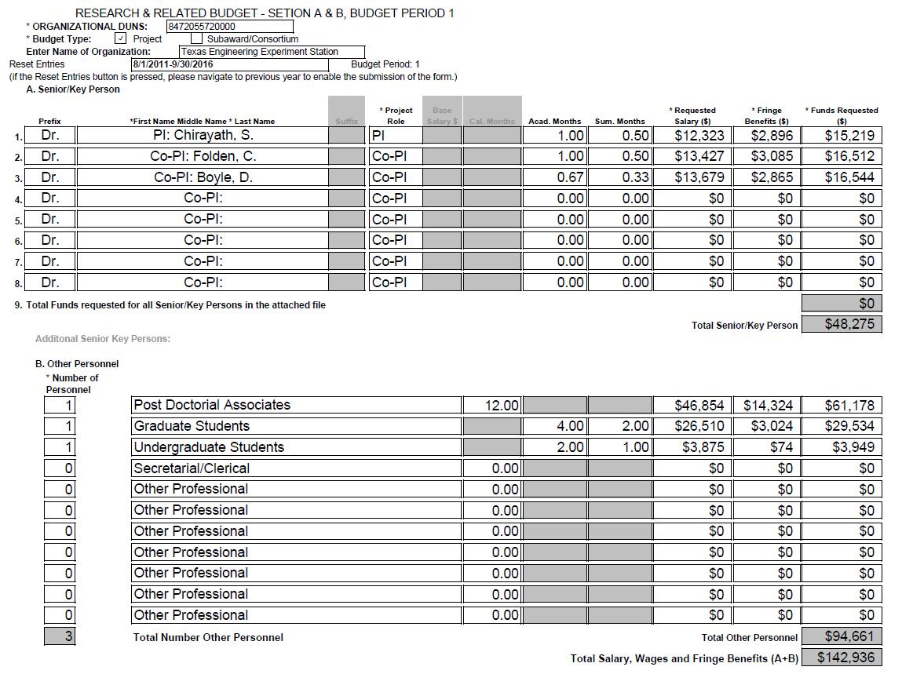
22
22
21
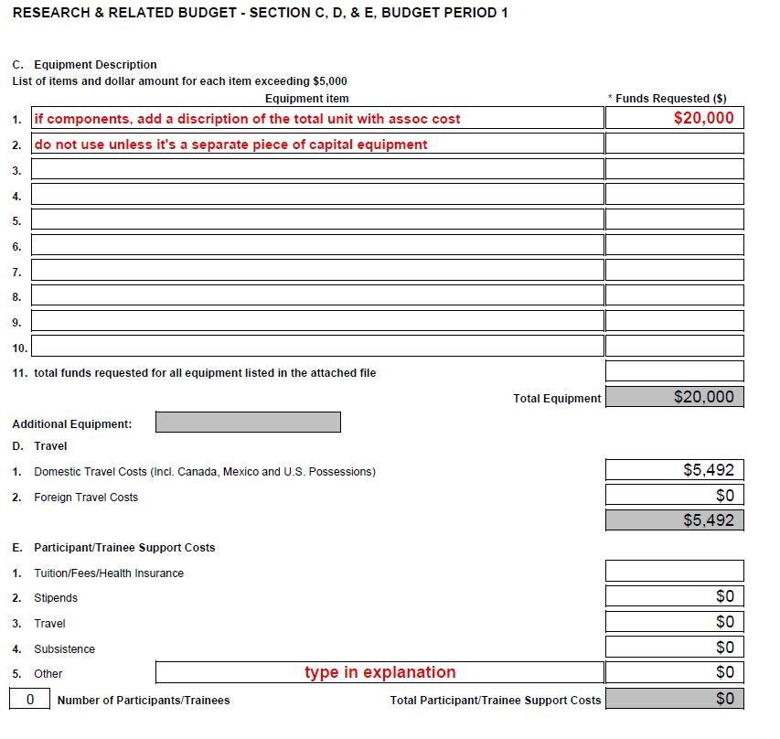

23

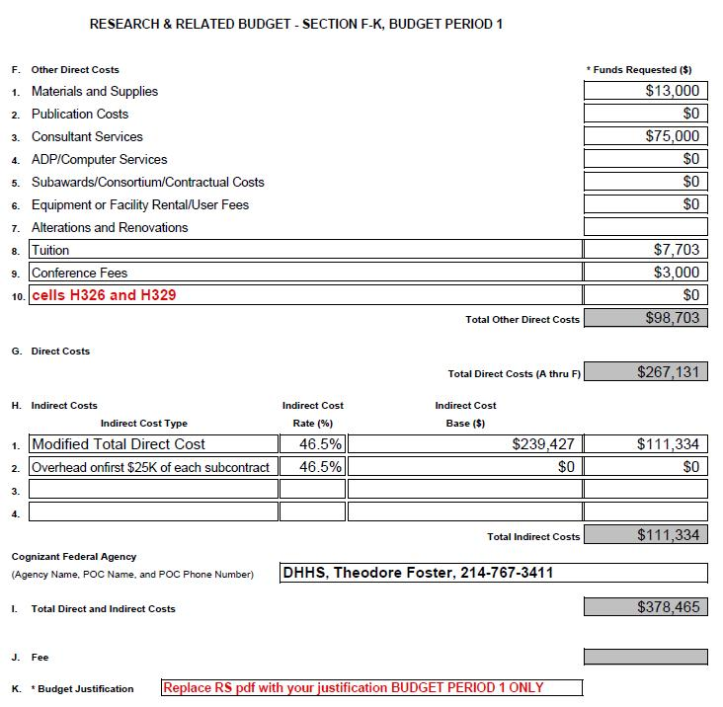

24

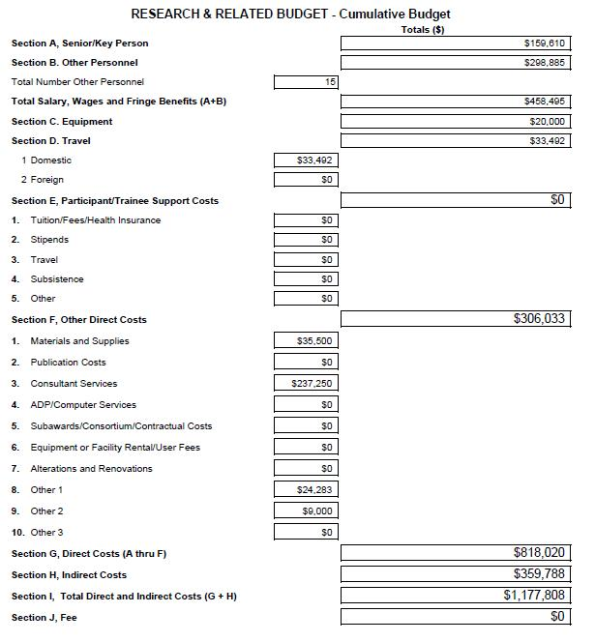
25

